User Manual

# Introduction

The program is a graphical user interface (GUI) application to execute the fundamental network diagnostic tool ping and display its raw output together with a histogram of Round Trip Time (RTT) values

# How to start it

## Compile

1. Open the cmd command line (Press Win + R, and input cmd, then press Enter)
2. Enter the location of the file (By using command "cd" )
3. Enter the text "javac NetAnalyser.java" in the command line

## Run

1. For Task1, Enter the text "java NetAnalyser" in the command line
2. For Task2 & Extra credit, Enter the text "java NetAnalyser number" in the command line

Note 1: The number is the maximum number of probes can be provided.

Note 2: The number should be an integer, between 10 and 20 inclusive, otherwise it will not work.

E.g. "java NetAnalyser 15" will display an interface allowing the user to select a number of probes between 1 and 15 inclusive.

# How to use it

Once launched with the command "java NetAnalyser" or " java NetAnalyser number", the interface look like *Figure 1*.

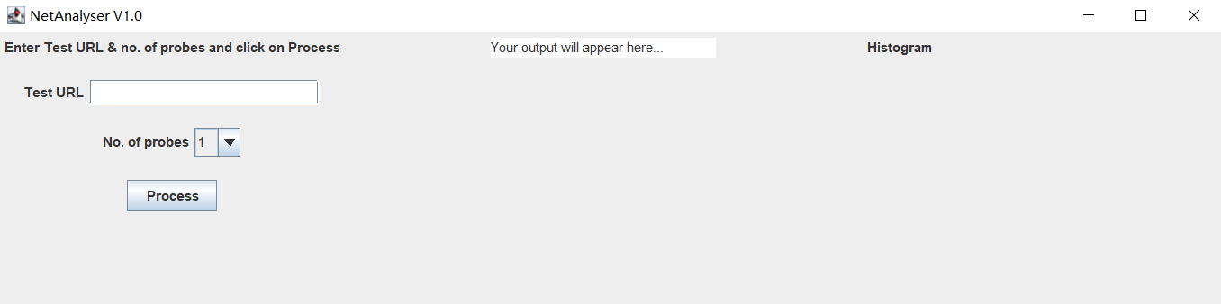

*Figure 1*

## Entered the Test URL

Note 1: For Task1 & Task 2, a valid URL will be provided and at least one probe will receive a reply with an RTT value, otherwise it will throws exception.

Note 2: For Extra credit, The following conditions will cause the program to exit.

1. No URL has been entered;
2. URL with no dots;
3. No reply lines (server cannot be reached);
4. All probes are "Request timed out".

## Selected the desired number of probes

For Task1, select a number of probes between 1 and 10 inclusive

For Task2 & Extra credit, select a number of probes between 1 and number(Entered in start process) inclusive.

## Press "Process" button

The middle section display the raw output from the ping command, and the right-hand section display a histogram of the RTT values, the interface look like *Figure 2*.

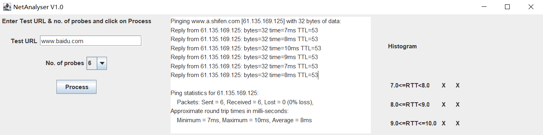

*Figure 2*

For Task2 & Extra credit, The histogram data in a text file along with date and time stamps as shown in Figure 3.

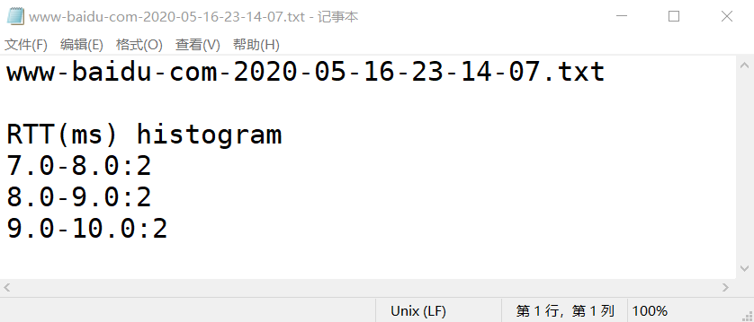

*Figure 3*